JECRC
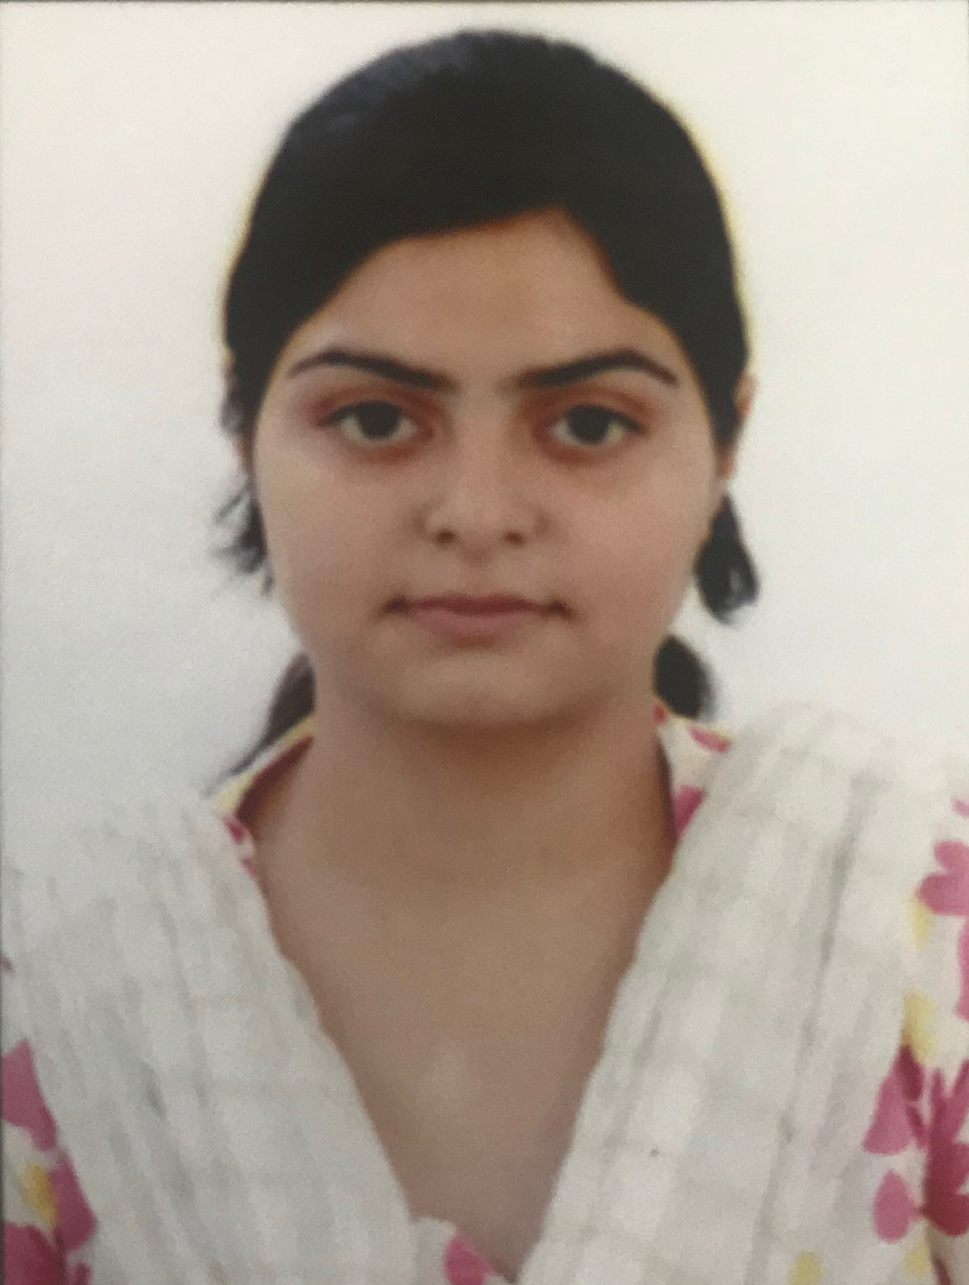
JAIPUR

INDIVIDUAL FACULTY DATA SHEET
Name of the faculty member | : | AAPURVA KAUL
Present Designation | : | ASSISTANT PROFESSOR
Email Id : aapurvakaul.ece@jecrc.ac.in
Contact Details : 8607788321

I. Particulars of Educational Qualification: (only completed)

Category | Name of the Degree | Specialization | Year of Passing | Name of the College | Name of the University
UG | B.TECH | ECE | 2013 | JAIPUR ENGINEERING COLLEGE RESERCH CENTRE, JAIPUR | RAJHASTHAN TECHNICAL UNIVERSITY, KOTA
PG | M.TECH | VLSI DESIGN | 2016 | MAHARISHI MARKANDESHWAR ENGINEERING COLLEGE, MULLANA | MAHARISHI MARKANDESHWAR UNIVERSITY, MULLANA-AMBALA
Ph.D. | -- | -- | -- | -- | --

II. Academic Experience : 9 MONTHS

III. Industrial Experience : --

IV. Title of Ph.D. Thesis : --

V. Awards/Achievements : Awarded with University Medal for securing First Class First Position in order with Distinction in Masters of Technology with specialization in VLSI Design (2014-2016).

VI. Research/Specialization : VHDL

VII. Course Taught : DIGITAL LOGIC DESIGN, MICROWAVE-II

VIII. Refereed International Journal Publication :

IX. International Conference Proceeding :

X. Books Written : --

XI. M.Tech Thesis Guide : MR. ABHIJEET KUMAR

XII. PHD Thesis Guide : --

XIII. Professional Body Membership : --

